Discussion Web

To put in a client name select all (ctrl A) then f9Nash Tech Software Development

**Detailed Design**

**Version 1.0**

**25th Nov, 2013**

364 CongHoa Street

VietNam

W1J 6QA

Tel: +84 (0)8 3810 6200

Fax: +84 (0)8 3810 6201

Email: [Tuan.NguyenLeAnh@harveynash.com](mailto:Tuan.NguyenLeAnh@harveynash.com)

DOCUMENT HISTORY

|  |  |  |  |  |
| --- | --- | --- | --- | --- |
| **Document Version History** | | | | |
| **Version** | **Date** | **Author** | **Reviewer** | **Details** |
| 0.1 | 25 November 2013 | Tuan Nguyen Le Anh |  | Create |
|  |  |  |  |  |
|  |  |  |  |  |
|  |  |  |  |  |

**APPROVERS**

|  |  |  |  |
| --- | --- | --- | --- |
|  | Name & Role | Date | Signature |
| **Originator** |  |  |  |
| **Reviewer/s** |  |  |  |
|  |  |  |  |
| **Approver/s** |  |  |  |

**CONFIDENTIALITY**

This document is distributed on a restricted basis, is commercial in confidence to the recipient, and may not be used for any purpose other than that associated with a Nash Tech project. The contents of this document may not be disclosed to any third parties without the expressed advance written authorisation of Nash Tech.

TABLE OF CONTENTS

1 INTRODUCTION 4

1.1 Purpose 4

1.2 Scope 4

1.3 Definitions, Acronyms and Abbreviations 4

1.4 References 4

1.5 Overview 4

2 DESIGN SEPECIFICATION FOR <THE SPECIFIED USE CASE> 4

2.1 Summary 4

2.2 Use case diagram 4

2.3 Activity Diagram 5

2.4 Sequence Diagram 7

2.5 Screens Design 10

2.5.1. Screen XYZ 10

2.6 Class Diagram 10

2.7 Class Specification (s) 11

2.7.1. Classes Summary 11

2.7.2. Class Details 12

**2.7.2.1.** **Class Account** 12

**2.7.2.1.1.** **Attributes** 12

**2.7.2.1.2.** **Methods** 12

**2.7.2.2.** **Class Topic** 12

**2.7.2.2.1.** **Attributes** 12

**2.7.2.2.2.** **Methods** 13

**2.7.2.3.** **Class Comment** 13

**2.7.2.3.1.** **Attributes** 13

**2.7.2.3.2.** **Methods** 13

# INTRODUCTION

This document will be created by developer and have to approve by PM, document help developer can implement code exactly that requirement wishes. The most important parts are design document, in particular are activity diagrams, class diagrams and sequence diagrams.

## Purpose

The main purpose is help developer can understand the functions, work flow and also the methods they are going to be implementing code. This document has to review and approve by project manager, as well as customer.

## Scope

Developer have to follow this document to implement their code, the document will affected the qualification of code.

## Definitions, Acronyms and Abbreviations

|  |  |
| --- | --- |
| **Acronym** | **Reference** |
| PM | Project Manager |
| UI | User Interface |
|  |  |

## References

1. From DDD homework as customer requirement on 23, November 2013
2. HNVN_TR_02027_DetailedDesignDocument_CoursePresentation.pdf at Course Material on Intranet.harveynash.vn
3. HNVN_TR_02027_DetailedDesignDocument_Diagrams_CoursePresentation.pdf at Course Material on Intranet.harveynash.vn

## Overview

In this session there are some important parts need to be clearly understood, Activity diagram, Sequence diagram, Class diagram

# DESIGN SEPECIFICATION FOR <THE SPECIFIED USE CASE>

## Summary

To be defined

## Use case diagram

## Activity Diagram

Login

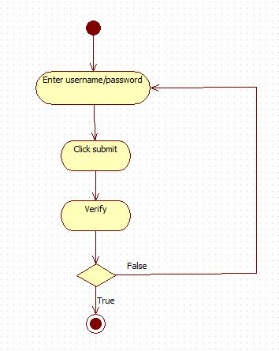

Post topic

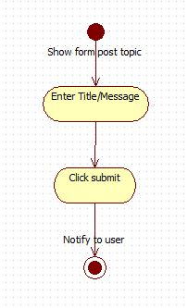

Delete topic

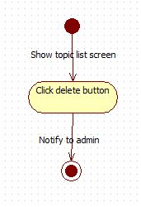

Lock topic

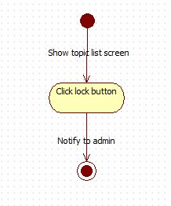

Post comment

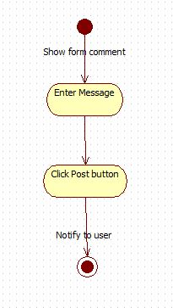

## Sequence Diagram

Login sequence diagram

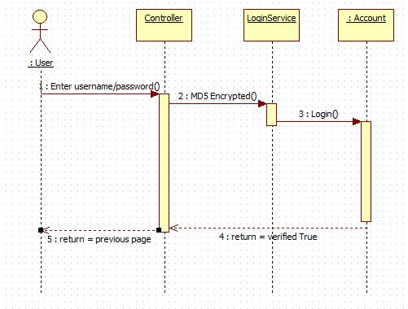

Post sequence diagram

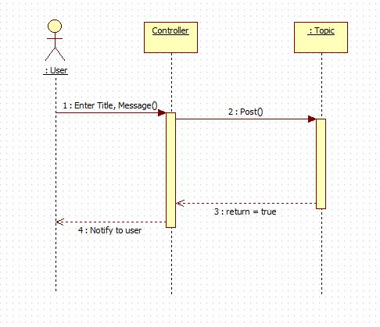

Show sequence diagram

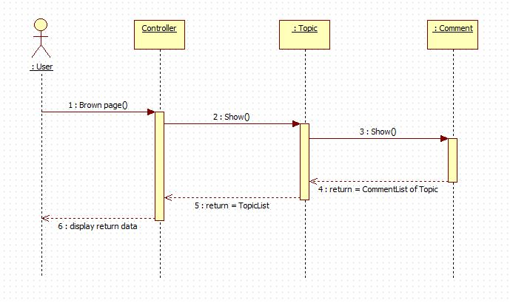

Delete topic sequence diagram

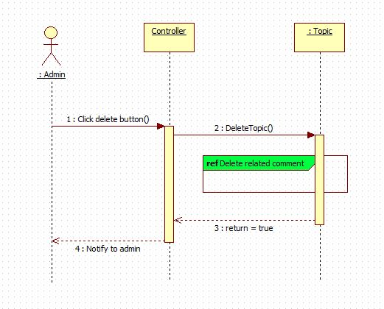

Lock topic sequence diagram

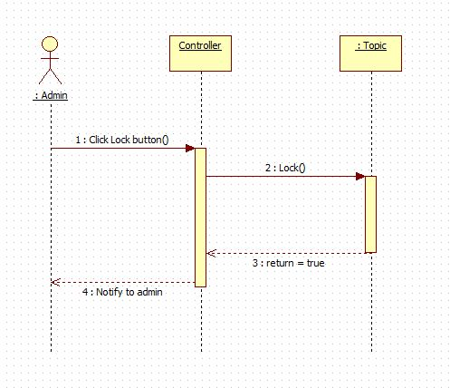

Post Comment sequence diagram

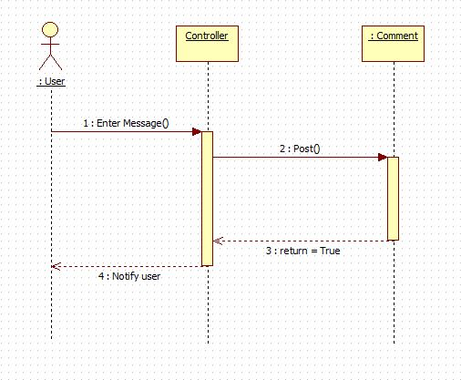

Delete comment diagram

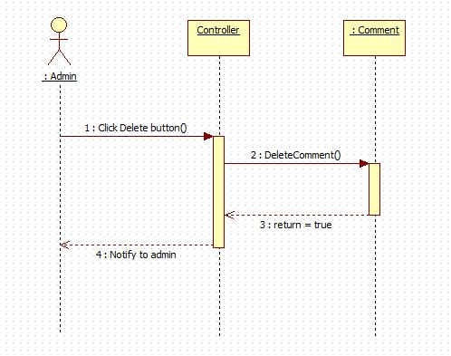

## Screens Design

### Screen XYZ

**Security Group**:

|  |  |  |
| --- | --- | --- |
| No | Data | Data Description |
| 01 | User Login / password | MD5 Encrytion |
|  |  |  |

|  |  |  |
| --- | --- | --- |
| No | Actions | Action Description |
|  |  |  |
|  |  |  |

## Class Diagram

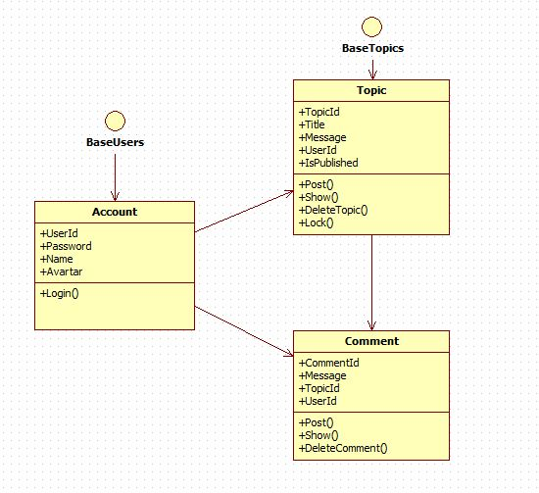

## Class Specification (s)

### Classes Summary

To be defined

### Class Details

#### **Class Account**

#### **Attributes**

|  |  |  |  |  |  |
| --- | --- | --- | --- | --- | --- |
| No | Attribute | Type | Default | Note | Description |
| 01 | UserId | String |  | Public/ Static | User name of user |
| 02 | Password | String |  | Private | Encrypted password |
| 03 | Name | String |  | Public | Full name of user |
| 04 | Avartar | String |  | Public | Url of avatar picture |

#### **Methods**

|  |  |  |
| --- | --- | --- |
| No | Method | Description |
| 01 | Login() | To verify user login to system |
|  |  |  |
|  |  |  |

#### **Class Topic**

#### **Attributes**

|  |  |  |  |  |  |
| --- | --- | --- | --- | --- | --- |
| No | Attribute | Type | Default | Note | Description |
| 01 | TopicId | Int |  | Public/ Static | Identity of topic |
| 02 | Title | String |  | Public | Title of topic |
| 03 | Message | String |  | Public | Content of topic |
| 04 | UserId | String |  | Public | User name of user |
| 05 | IsPublished | Boolean |  | Publich | The topic published or not |

#### **Methods**

|  |  |  |
| --- | --- | --- |
| No | Method | Description |
| 01 | Post() | Post a new topic |
| 02 | Show() | Shows a list of topic |
| 03 | DeleteTopic() | Delete a topic |
| 04 | Lock() | Lock a topic |

#### **Class Comment**

#### **Attributes**

|  |  |  |  |  |  |
| --- | --- | --- | --- | --- | --- |
| No | Attribute | Type | Default | Note | Description |
| 01 | Message | String |  | Public | Content of comment/discuss |
| 02 | TopicId | Int |  | Public | Id of topic |
| 03 | UserId | String |  | Public | User name of user |

#### **Methods**

|  |  |  |
| --- | --- | --- |
| No | Method | Description |
| 01 | Post() | Post new comment in a topic |
| 02 | Show() | Shows comments of a topic |
| 03 | DeleteComment() | Delete a comment |

#### **Login Method**

|  |  |
| --- | --- |
| **Declaration** | |
| **Method Declaration** |  |
| **Description** | Login method will accept two arguments. Password must be encrypted MD5 |
| **Overrides** | |
| Not Applicable. | |
| **Parameter** | |
| **Name** | **Type** |
| **Username** | **string** |
| **Password** | **string** |
|  |  |
| **Return Type** | |
| Boolean | |
| **Throws** | |
| Null exception | |

#### **Post Topic Method**

|  |  |
| --- | --- |
| **Declaration** | |
| **Method Declaration** |  |
| **Description** | Post a new topic by user |
| **Overrides** | |
| Not Applicable. | |
| **Parameter** | |
| **Name** | **Type** |
| **Title** | **String** |
| **Message** | **String** |
|  |  |
| **Return Type** | |
| Boolean | |
| **Throws** | |
| Null exception | |

#### **Show Topic Method**

|  |  |
| --- | --- |
| **Declaration** | |
| **Method Declaration** |  |
| **Description** | Show all topic for user and admin |
| **Overrides** | |
| Not Applicable. | |
| **Parameter** | |
| **Name** | **Type** |
| **IsAdmin** | **Boolean** |
|  |  |
|  |  |
| **Return Type** | |
| ListTopic | |
| **Throws** | |
|  | |

#### **Delete Topic Method**

|  |  |
| --- | --- |
| **Declaration** | |
| **Method Declaration** |  |
| **Description** | Delete a topic |
| **Overrides** | |
| Not Applicable. | |
| **Parameter** | |
| **Name** | **Type** |
| **TopicId** | **Int** |
|  |  |
|  |  |
| **Return Type** | |
| Boolean | |
| **Throws** | |
|  | |

#### **Lock Topic Method**

|  |  |
| --- | --- |
| **Declaration** | |
| **Method Declaration** |  |
| **Description** | Lock a topic by admin |
| **Overrides** | |
| Not Applicable. | |
| **Parameter** | |
| **Name** | **Type** |
| **TopicId** | **Int** |
|  |  |
|  |  |
| **Return Type** | |
| Boolean | |
| **Throws** | |
|  | |

#### **Post Comment Method**

|  |  |
| --- | --- |
| **Declaration** | |
| **Method Declaration** |  |
| **Description** | Post a comment in a topic by user |
| **Overrides** | |
| Not Applicable. | |
| **Parameter** | |
| **Name** | **Type** |
| **Message** | **String** |
| **TopicId** | **Int** |
| **UserId** | **String** |
| **Return Type** | |
| Boolean | |
| **Throws** | |
| Null exception | |

#### **Show Comment Method**

|  |  |
| --- | --- |
| **Declaration** | |
| **Method Declaration** |  |
| **Description** | Show comments in a topic |
| **Overrides** | |
| Not Applicable. | |
| **Parameter** | |
| **Name** | **Type** |
| **TopicId** | **Int** |
|  |  |
|  |  |
| **Return Type** | |
| CommentList | |
| **Throws** | |
|  | |

#### **Delete Comment Method**

|  |  |
| --- | --- |
| **Declaration** | |
| **Method Declaration** |  |
| **Description** | Delete a comment |
| **Overrides** | |
| Not Applicable. | |
| **Parameter** | |
| **Name** | **Type** |
| **CommentId** | **Int** |
|  |  |
|  |  |
| **Return Type** | |
| Boolean | |
| **Throws** | |
|  | |

##### Implementation